**LAB # 9**

**Backend development with Node + Express js, and testing with postman**

**OBJECTIVE:**

To introduce students to the basic concepts of backend development.

**Download and install these softwares to perform lab:**

VS Code download link: <https://code.visualstudio.com/download>

Node js download link: <https://nodejs.org/en/download>

Postman download link: <https://www.postman.com/downloads/>

**Backend development:**

Create a folder name “backend”.

Open backend folder in vs code.

You will see screen like this:

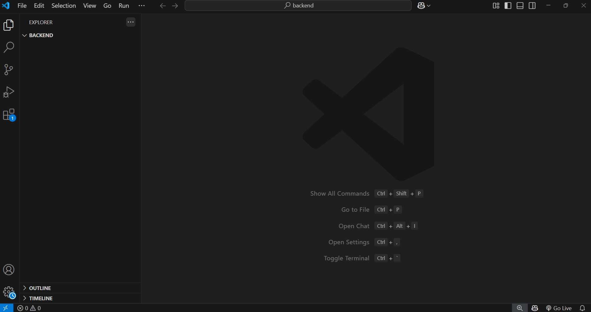

Open terminal by using **ctrl + `** key on keyboard:

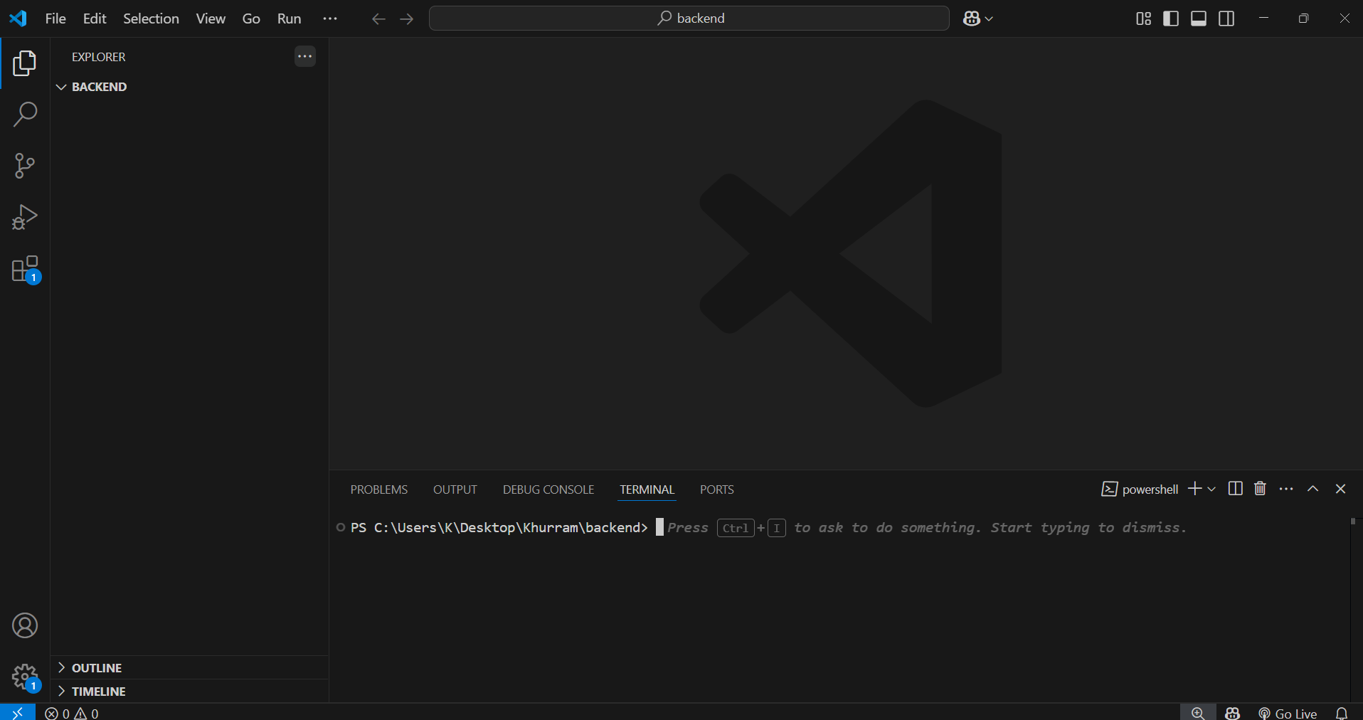

Type this command in terminal:

**npm init –y**

This will create a package.json file:

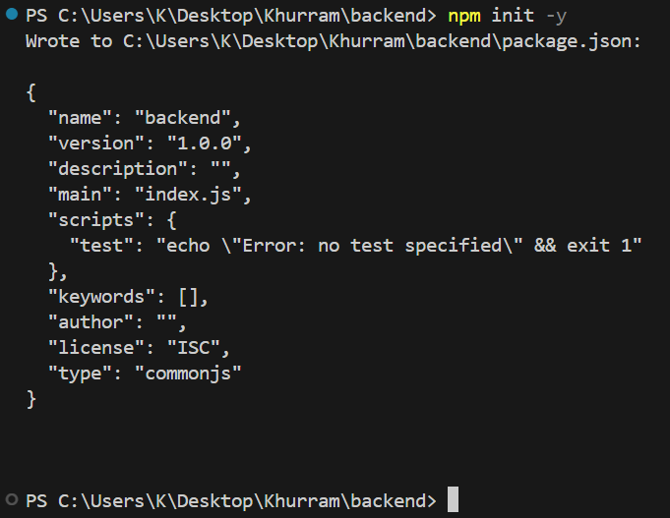

Install required packages by typing the following command:

**npm install express cors**

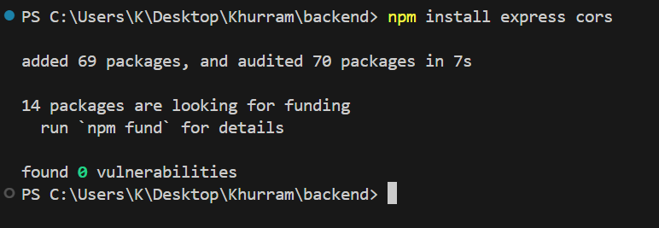

You can check package.json file:

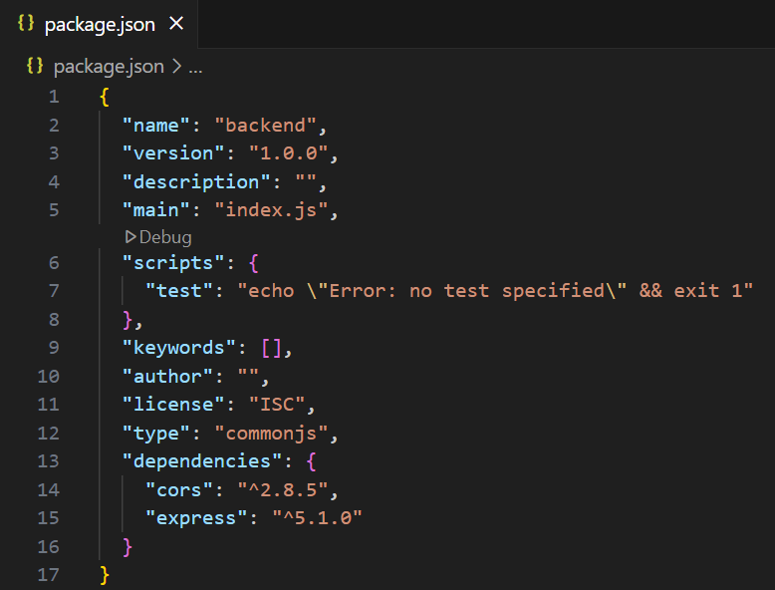

Now create a file name server.js.

**server.js:**

// Backend api bana rahay hain,

// by using Express js framework

// jis mai Create, Read, Update or Delete Operations perform ho gain.

// Task ko easy rakhne k liye, only username pay kaam hoga

// Let suppose k username save kia

// Read kia etc etc

// Express aik tarah ka node ka backend framework hai.

// Express server banane k kaam aata hai.

const express = require('express');

// CORS stands for Cross-Origin Resource Sharing.

// Let suppose k ap ka backend http://localhost:5000 pay run kar raha hai.

// And frontend http://localhost:3000 pay run kar raha hai.

// To cors ap ko allow karta hai k ap do different links say.

// data ki sharing kr saktay hain.

// Is wajah say he ye Cross-Origin Resource Sharing (CORS) kehal aata hai.

const cors = require('cors');

// Express ki app bana rahay hain

const app = express();

// App k sath cors use kar rahay hain.

// Takay future mai koi problem nhi ho.

app.use(cors());

// "JSON" stands for JavaScript Object Notation.

// Json yani key:value type k data pay kaam karain gain.

// For example:

/*

{

    "username":"User_1"

}

*/

// To json use kar rahay hain.

app.use(express.json());

// Abhi koi database nhi use kia.

// To data ko array mai save karain gain.

// Or har user ki aik id hogi vo bhi.

let users = [];

let nextId = 1;

// Post request say data create kartay hain.

// Yani data save karne k liye request send ki hai.

// Postman software open kro.

// Post request select karo.

// ye link likho:

// http://localhost:5000/api/post

// Body mai ye data likho:

/*

{

    "username":"Test User"

}

*/

app.post('/api/post', (req, res) => {

    // Request say data ko data variable mai save kar liya.

    let data = req.body;

    // Aik new object create kia id vo use ki jo upper create ki thi.

    // Phir data.username mai say username object mai add kar dia.

    const newUser = {

        id: nextId++,

        username: data.username

    };

    // Ab object ko users k array mai push kar dia.

    users.push(newUser);

    // End mai response send kia.

    // Response mai do cheeze send ki:

    // Aik status code 201 jis ka matlub hota hai k successfully created.

    // Dosra newUser ka object return kia takay pata chale k kia data save kia hai.

    res.status(201).json(newUser);

});

// Get request say data read kartay hain.

// Ye Get request sab data ko get kr k,

// JSON ki form mai ap ko reqponse day gi.

// Postman software open kro.

// Get request select karo.

// ye link likho:

// http://localhost:5000/api/get

app.get('/api/get', (req, res) => {

    // Sab data lay k 200 status code k sath return kr raha hai

    res.status(200).json(users);

});

// Let suppose k agar only one username chiye,

// to ap ki Get request kuch is tarah ki hogi,

// k ap get request k end mai user id put karain gain.

// Postman software open kro.

// Get request select karo.

// ye link likho:

// http://localhost:5000/api/get/2

// Yaad rahay link k end mai ap id koi bhi day saktay ho.

app.get('/api/get/:id', (req, res) => {

    // Jo id ap link ko do,

    // vo server ko req.params.id say milay gi,

    // phir id ko userId k variable mai save kia.

    let userId = parseInt(req.params.id);

    // Ab users mai vo id find karay ga,

    // agar username mil gia,

    // to vo user k object ko user variable mai save kare ga.

    let user = users.find(u => u.id === userId);

    // Ab vo aik user k data ko,

    // status code 200 k sath return karde ga.

    res.status(200).json(user);

});

// Put request update karne ka kaam karti hai.

// Postman software open kro.

// Put request select karo.

// ye link likho:

// http://localhost:5000/api/put/2

// Yaad rahay link k end mai ap id koi bhi day saktay ho.

// Body mai ye data ai ga:

/*

{

    "username":"User 2"

}

*/

app.put('/api/put/:id', (req, res) => {

    // Jo id ap link ko do,

    // vo server ko req.params.id say milay gi,

    // phir id ko userId k variable mai save kia.

    let userId = parseInt(req.params.id);

    // Sab data a k data variable mai save hoga.

    let data = req.body;

    // Ab users mai vo id find karay ga,

    // agar username mil gia,

    // to vo user k object ko user variable mai save kare ga.

    let user = users.find(u => u.id === userId);

    // username ko update kr raha hai.

    user.username = data.username;

    // Ab vo aik user k data ko,

    // status code 200 k sath return karde ga.

    res.status(200).json(user);

});

// Delete request delete karne ka kaam karti hai.

// Postman software open kro.

// Delete request select karo.

// ye link likho:

// http://localhost:5000/api/delete/2

// Yaad rahay link k end mai ap id koi bhi day saktay ho.

app.delete('/api/delete/:id', (req, res) => {

    // Jo id ap link ko do,

    // vo server ko req.params.id say milay gi,

    // phir id ko userId k variable mai save kia.

    let userId = parseInt(req.params.id);

    // users k array mai say us object ka index find kare ga,

    // jis k data ko delete karna hai.

    let index = users.findIndex(u => u.id === userId);

    // Data ko delete kr k aik array return kr raha hai,

    // jis array k 0 index pay vo delete ho chuka object hai.

    let deletedUserData = users.splice(index, 1);

    res.status(200).json(deletedUserData[0]);

});

// Aik constant PORT jis mai 5000 save kia or app ko start kia port 5000 pay.

const PORT = 5000;

app.listen(PORT, () => {

    // console.log() ki command print karne ka kaam karti hai

    console.log(`Server running on http://localhost:${PORT}`);

});

Now press **ctrl + s** to save the file.

Now run this command in terminal, to start server:

**node server.js**

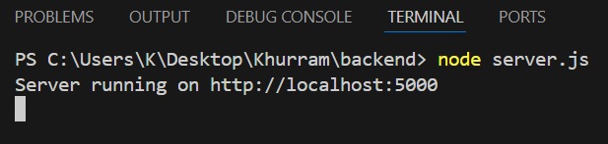

**Backend Testing:**

Now for testing backend, we use Postman software:

**Post request:**

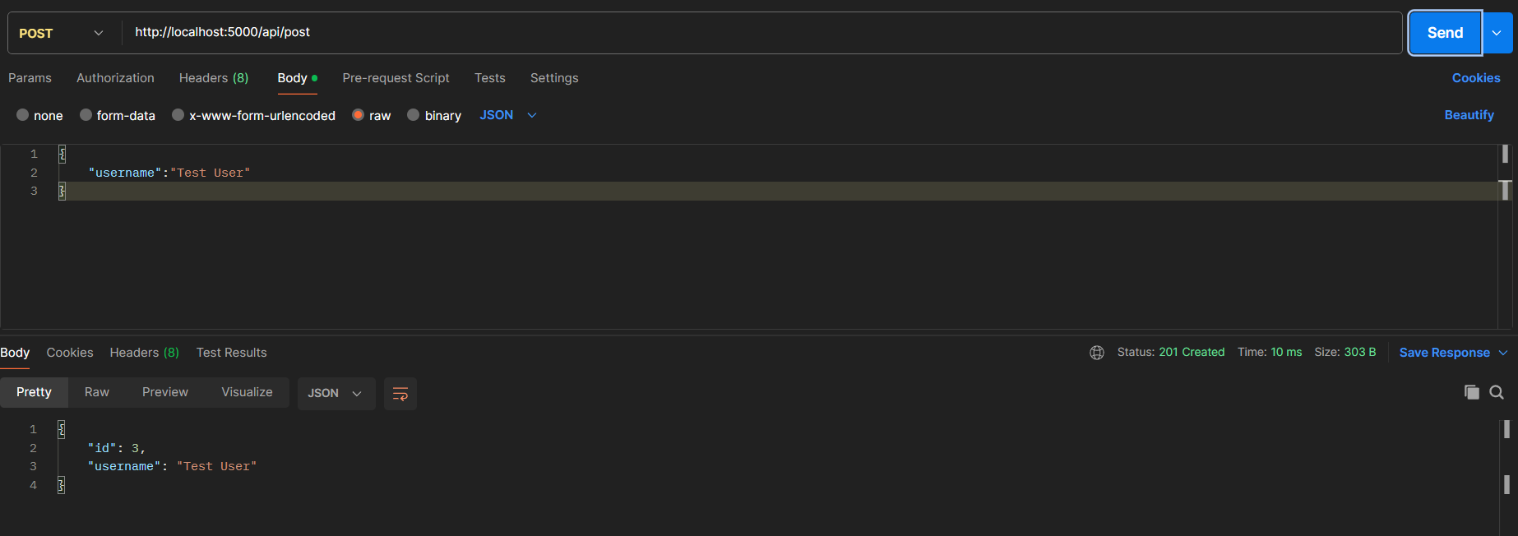

**Get request:**

**Get data of all users:**

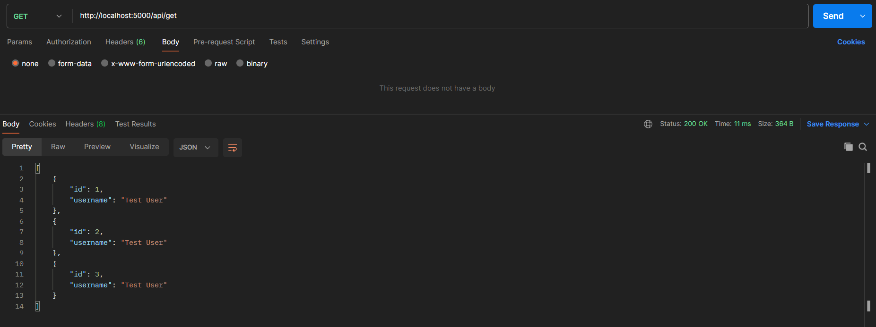

**Get data of one user:**

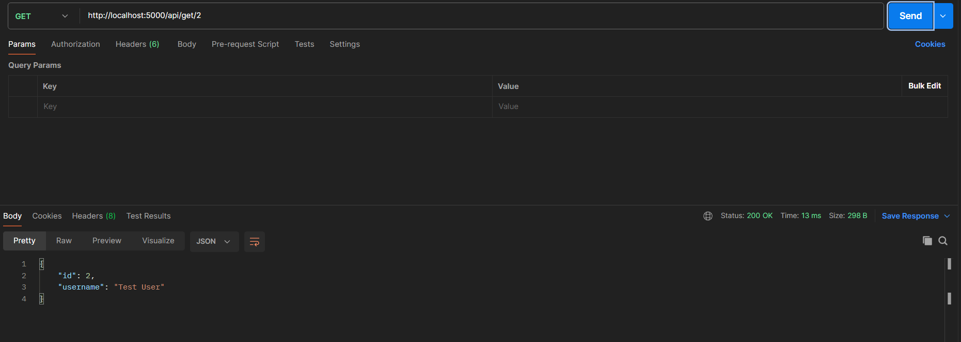

**Put request:**

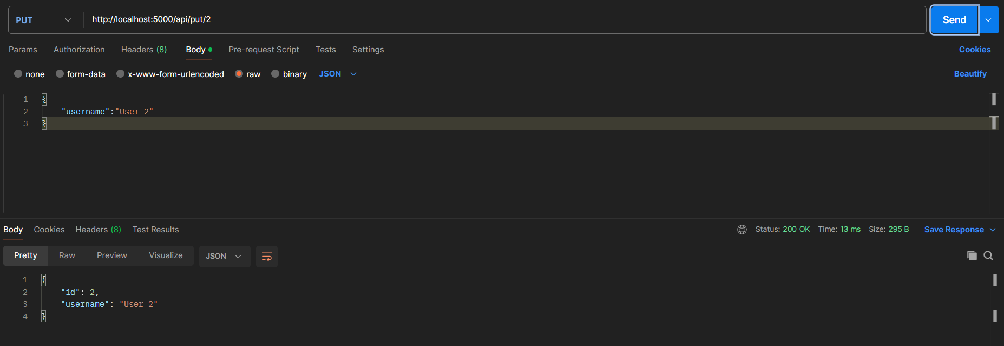

**Delete request:**

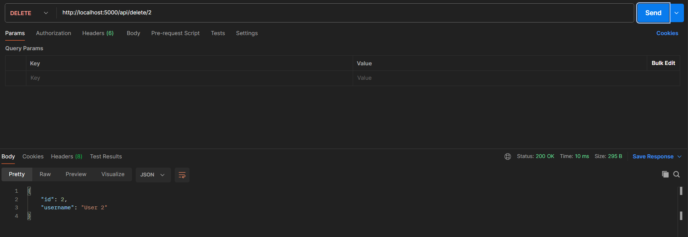

**Lab Task:**

Create a calculator by using Express js and include these methods: post, get, put and delete.